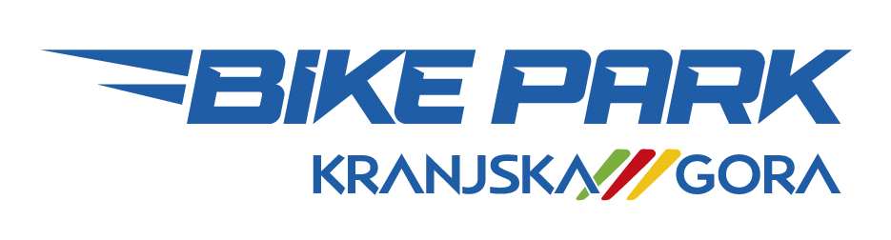

TERMS AND CONDITIONS FOR THE USE
OF KRANJSKA GORA BIKE PARK

- Riders use the bike park trails at their own risk. The operator of Žičnice Kranjska Gora
accepts no responsibility for any damage or injury that may occur as a result of riding bike park trails
nor is it responsible for any stolen items during the use of the park.
- The use of trails under the influence of alcohol or any other drugs is not permitted. Persons who are subjects to epileptic seizures will also be denied entry.
- Parents’ signed consent is required for riders under 18 years of age. A parent or guardian
must accompany riders aged 15 and under.
- Parents are responsible for the safety of their children.
- The trails are not suitable for total beginners.
- Riders must wear helmet at all times. The use of safety equipment is strongly recommended
- (Knee and elbow guards, body armour).
- Use only mountain bikes that are suitable for the trails.
- Riders are advised to always inspect trails before attempting them.
- Riders must adjust their speed to trail and weather conditions, as well as their own riding capabilities.
- Ride within your limits in order to minimise the risk of accident and injury to yourself and other riders.
- Riders must strictly follow the specified trail direction at all times.
- Riders are not allowed to adapt or change the trails and trail objects in any way.
- Riding or walking up the trail is not permitted.
- The lift ticket is non-transferable.
- The use of Kranjska Gora bike park trails is only allowed during operating hours.
- Dogs and other pets are not allowed.
- Riders who will disregard these terms and conditions will be asked to leave the premises without ticket refund.
- No refund is given on lift tickets in case of bad weather (strong rain, strong winds, forecasted lighting strikes...) or other unforeseen interruptions that are beyond the control of the operations management. In case of rider’s early departure, no refund will be given, as well.
- Bikes are transported with the chair-lift at the rider’s own risk. Regardless of the way they were put on the chair hook (alone or with assistance of the chair-lift operator) the operator of Žičnice Kranjska Gora takes no responsibility for the possible damage to the bikes.
- In case of an accident please notify a member of staff immediately or call 112.

I hereby confirm that I have carefully read and that I understand terms and conditions for the use of
Kranjska Gora bike park. I agree to use the bike park in accordance with these terms and conditions and
at my own risk. I will not hold operators of the park responsible in case of injury or damage.

Name: …….………………………………………........... Date: ………………………...……

Address: ………………………………………….............

Place, postal code: ………………………………………. Signature:

E-mail: ………………………………………………......... ………………………………………

Parent’s consent (for persons younger than 18 years of age):

I (name) …………………………………….… hereby agree that my child (name) ………………………………………
uses the Kranjska Gora bike park. His/her safety is my own responsibility.

Signature: ……………………………………...

I hereby give my consent to company RTC Žičnice, Kranjska Gora, d.o.o., to collect and use data given in this agreement according to the GDPR law (protection of personal data). We respect your privacy and are committed to provide security of your personal data. Details about privacy protection including your right to cancel your agreement at any time is described on our website www.ski-kranjska-gora.com or in a written form at the cash desk.

